Supporters’ Club Newsletter – JANUARY 2009

I am happy to report another successful year for both the Team and, in a modest way, the Supporters’ Club. The latter has maintained its numbers by recruiting new members to replace those who donated to the project at the outset but who were in reality making a one-off donation. Many of our individual and family members now subscribe by standing order which, with gift aid, significantly increases the income of the Team - a charity funded entirely by donations. During 2008 the base has been improved and the number of call-outs was down, the latter being good news for our potential clients!  Team numbers remain on target with 33 on the Call-out List, including Dave George and Jacqui Young who have just moved from probationer status, and with an additional 5 new probationers joining in January 2009. The Active, or Call-out, List is reviewed every 6 months and anyone with low training or call-out attendance, due perhaps to illness or work pressure, is moved to the Associate List. The reverse also occurs for any associate who has been | 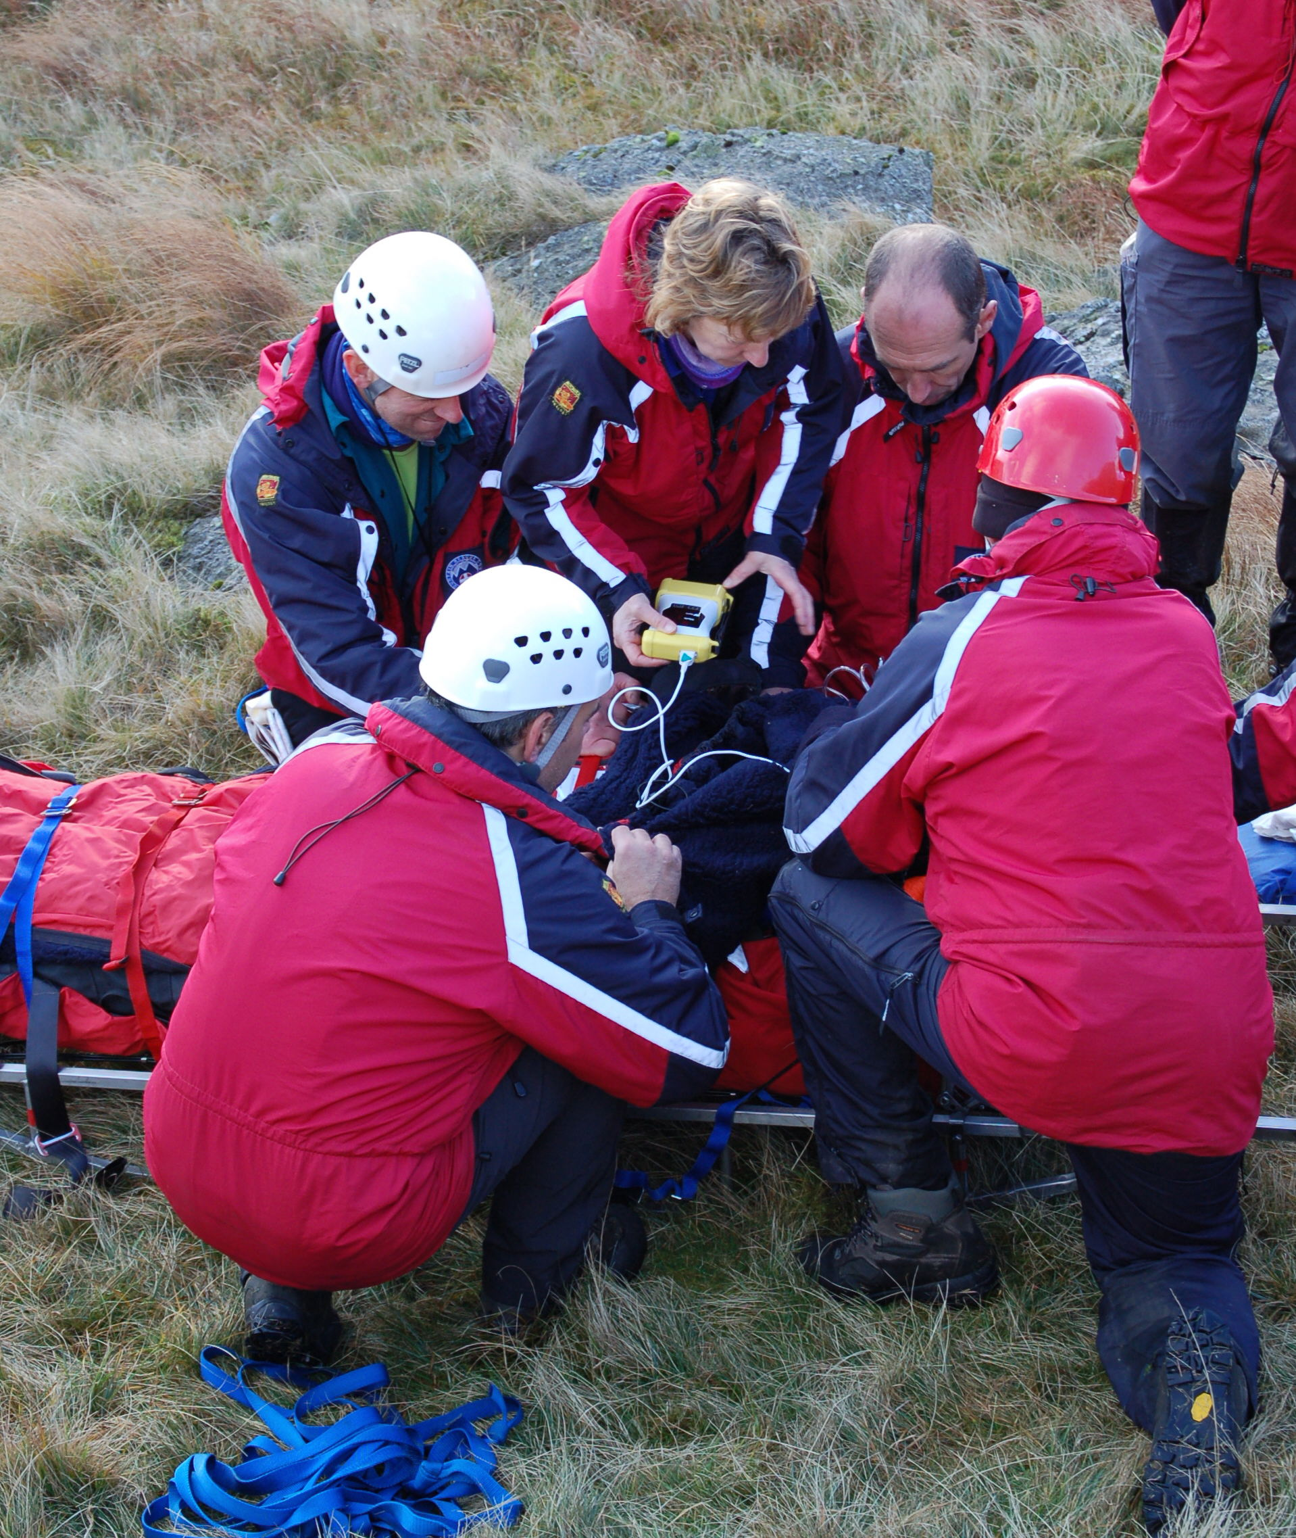
able to increase their training attendance and in this way we were pleased to welcome back Les Brown after a break. John Leadbetter’s dog Skye, after nearly two years training in which many team members have been involved, is about to become qualified as a search and rescue dog. This will be a significant resource for us and for other local teams in 2009.

The Team has a good balance of members covering a wide range of professions, from outdoor pursuits, industrial safety, IT, ex-services, education and medical to various roles associated with the nuclear industry at Sellafield. This mixture gives the Team a high degree of professionalism and we pride ourselves on our adaptability, depth of experience and tautness of operational procedures. Medical and C³ (command, control & communications) training are given a high training priority with 82% of members qualified with the Mountain Rescue Casualty Care certificate, while the remainder have a basic first aid qualification. Communications is an area in which we lead the field with Dave Binks ever active in improving our radio and GPS coverage so that we can now control our large area from Foxfield base.

As planned the hierarchy has changed with Mike Margeson now firmly in control of operational matters and Pete Jackson assuming the position of a normal member after 40 years as team leader. In September a party was held to recognize Dave Hughes’s 40 years in the team. Stephe Cove continues as chairman of the charity, having stood in during a gap 25 years ago.

During 2008 we were involved with 5 individual lost, or at least overdue, walkers. These included one who regrettably had suffered a fatal heart attack, one who was potentially suicidal, a mental health patient and an elderly lady suffering from hypothermia after a winter’s night out from her care home.
There were also 2 pairs of walkers requiring night searches, a school party lost somewhere in the Duddon valley and a party of 3-peakers somewhere in the Upper Esk. All were found safe. We dealt with a fallen climber on Wallowbarrow (filmed on Channel 5’s “Highland Emergency”, pictured right), a girl with a broken pelvis who had fallen into the River Duddon, a boy who broke his arm falling down a cliff near Cark, a young lady potentially seriously injured in a trail bike accident and a man with a broken leg who had fallen off his quad bike.  Other more unusual call outs included the search for a lady whose car had been washed away in a flooded river and sadly whose body was found some miles downstream. A request to support the Wasdale Team with communications for an extensive search was answered by a small team. On another occasion the Army was called in to blow up an old mortar shell found by team members, dating back to when parts of the Lakes were used for military training. Some individual team members were also involved in call outs with other teams.  Several of our call outs were in support of adjacent teams, in | 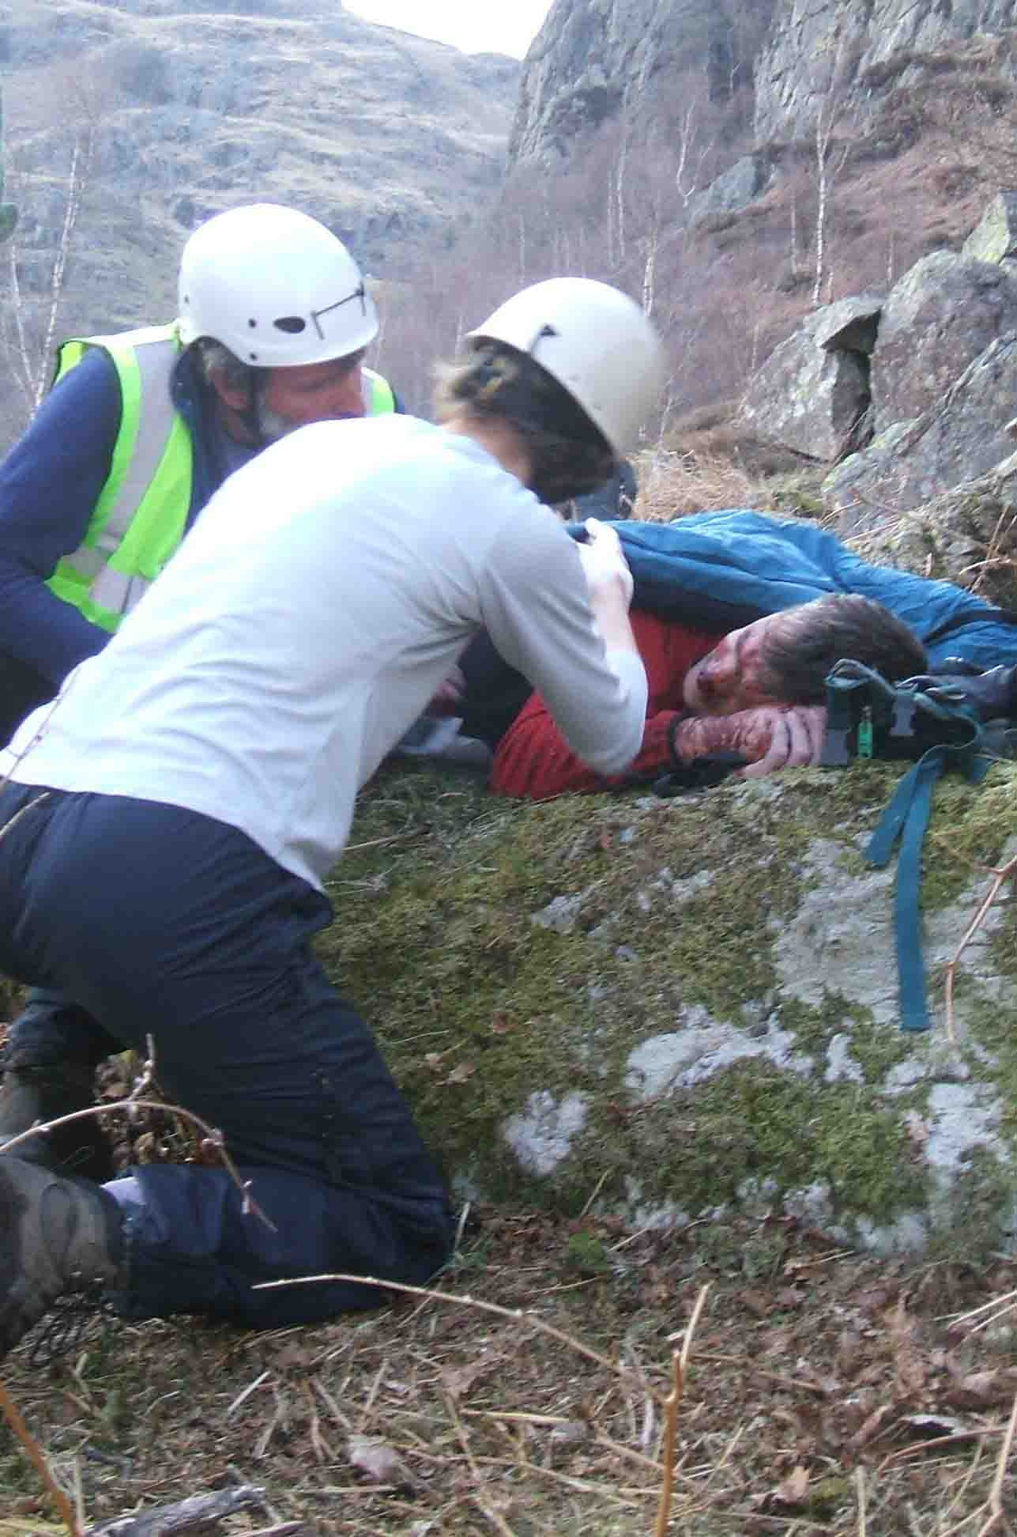
particular Wasdale and Kendal, walkers possibly having strayed across team boundaries, to assist in a larger incident or when another team is over-committed. We also work closely with Police and Ambulance services, with a member of each represented in the Team, and occasionally with the Coast Guards; and quite often, as can be seen from the above call outs, in support of the local community.

The full team also conducted 14 training/practice days and 20 training evenings. Individual members or groups of members attended a myriad of additional training, fund raising and PR events as well as regular meetings and administrative work.

Last year I reported that our base was to be improved. This has happened and we now have better access for the vehicles, a drying room and most importantly a purpose built control room with everything to hand - and a modicum of comfort for those spending a night on duty there.  With the improvement and unpredictability of the weather in Cumbria the Team has for some years spent a weekend training in the Highlands of Scotland to ensure that members are proficient in snow and ice conditions, which only occasionally occur in Cumbria. This has become a great social as well as training weekend.  Team funds are fairly healthy at present but with one of the Land Rovers due for replacement after 12 years service and a never-ending need to replace medical and technical equipment as it reaches the end of its life the need for your donations continues.  The final event of 2008 was Christmas drinks at the Prince of Wales at Foxfield marking the end of another successful year and helping to maintain team morale. This is vitally important if we are to continue to flourish as a volunteer organisation expecting members to turn out 365 days a year, at all times of day and night  and in all weathers. | 

